ECONOMICS Examination 2015
ATAR Year 11 – Units 1 and 2

Student Name: __________________________________________

Time allowed for this paper
Reading time before commencing work: ten minutes
Working time for paper: three hours

Materials required/recommended for this paper
To be provided by the supervisor
This Question/Answer Booklet
Multiple-choice Answer Sheet

To be provided by the candidate
Standard items: pens (blue/black preferred), pencils (including coloured), sharpener, correction fluid/tape, eraser, ruler, highlighters
Special items: non-programmable calculators approved for use in the WACE examinations

Important note to candidates
No other items may be taken into the examination room. It is your responsibility to ensure that you do not have any unauthorised notes or other items of a non-personal nature in the examination room. If you have any unauthorised material with you, hand it to the supervisor before reading any further.

Structure of this paper

SECTION | FORMAT | NO. OF QUESTIONS AVAILABLE | NO. OF QUESTIONS TO BE ATTEMPTED | SUGGESTED TIME / MINUTES | MARKS
1 | Multiple Choice | 24 | ALL | 35 | 24
2 | Data Interpretation and short answer | 3 | ALL | 65 | 36
3 | Sectionalised long answer | 4 | 2 | 80 | 40

Instructions to candidates

1. Answer the questions according to the following instructions.
Section One: Answer all questions on the separate Multiple-choice Answer Sheet provided. For each question, shade the box to indicate your answer. Use only a blue or black pen to shade the boxes. If you make a mistake, place a cross through that square, then shade your new answer. Do not erase or use correction fluid/tape. Marks will not be deducted for incorrect answers. No marks will be given if more than one answer is completed for any question.
Sections Two and Three: Write your answers in this Question/Answer Booklet.

2. You must be careful to confine your responses to the specific questions asked and to follow any instructions that are specific to a particular question.

3. Spare pages are included at the end of this booklet. They can be used for planning your responses and/or as additional space if required to continue an answer.
● Planning: If you use the spare pages for planning, indicate this clearly at the top of the page.
● Continuing an answer: If you need to use the space to continue an answer, indicate in the original answer space where the answer is continued, i.e. give the page number. Fill in the number of the question that you are continuing to answer at the top of the page.

See next page
Section 1: Multiple Choice (24 Marks)
This section has 24 questions. Answer all questions on the separate Multiple-choice Answer Sheet provided. Marks will not be deducted for incorrect answers. No marks will be given if more than one answer is completed for any question.

Suggested working time: 35 minutes
___________________________________________________________________

1. If the price of mandarins increases, the price of oranges also rises because
A. consumers consider the two goods complements and so sellers decreased the supply of oranges.
B. consumers consider the two goods substitutes and demand for oranges increases.
C. if the supply of mandarins decreased, then the supply of oranges also must decrease.
D. buyers must have expected a higher price for oranges and thus increased their demand for oranges.

2. Suppose that a just published report on the health effects of riding bicycles causes demand to increase. As a result of the increased demand, more firms enter the market to produce bicycles and the supply of bicycles increases. We can predict that
A. the prices of bicycles will increase.
B. the prices of bicycles will decrease.
C. the prices of bicycles will remain the same.
D. we cannot predict the price of bicycles with the information provided.

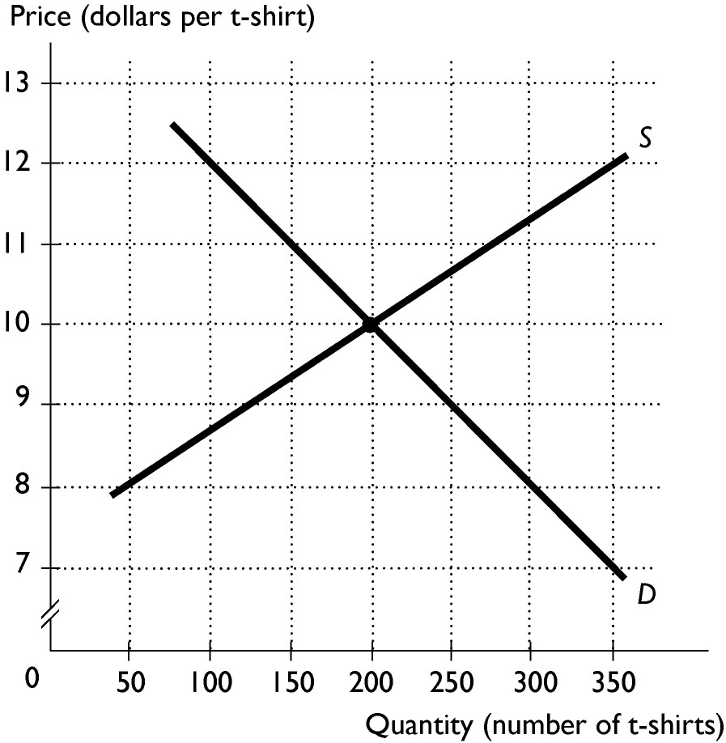
3. The figure shows the market for t-shirts. If the price of t-shirts is $12, then
A. there is a shortage and the price of t-shirts will fall.
B. there is a shortage and the price of t-shirts will rise.
C. there is a surplus and the price of t-shirts will rise.
D. there is a surplus and the price of t-shirts will fall.

See next page
4. The price elasticity of demand for furniture is estimated at 1.3. This value means a one percent increase in the
A. price of furniture will increase the quantity of furniture demanded by 1.3 percent.
B. price of furniture will decrease the quantity of furniture demanded by 1.3 percent.
C. quantity of furniture demanded will decrease the price of furniture by 1.3 percent.
D. quantity of furniture demanded will increase the price of furniture by 1.3 percent.

5. If Sam wants to increase her total revenue from her sales of flowers and she knows that the demand for flowers is price elastic, she should
A. lower her price to increase the demand and shift the demand curve rightward.
B. raise her price because she knows that the quantity demanded will also increase.
C. raise her price because she knows that the percentage decrease in the quantity demanded will be smaller than the percentage increase in price.
D. lower her price because she knows that the percentage increase in the quantity demanded will be greater than the percentage decrease in price.

6. Toothpaste and toothbrushes are complements, so the ________ elasticity of demand is ________.
A. cross; positive
B. income; negative
C. cross; negative
D. income; positive

7. If the income elasticity for chocolate chip cookies is 1.8, then chocolate chip cookies are
A. a normal good and income elastic.
B. a normal good and income inelastic.
C. an inferior good and income inelastic.
D. an inferior good and income elastic.

8. The latest model car in the dealer's showroom has a sticker price of $35,000.00. Fred, the shopper, has decided that he would pay no more than $32,000.00 for the car. After two hours of bargaining with the saleswoman, Fred actually purchases the car for $31,000.00. Fred, therefore, has obtained a consumer surplus of
A. $1,000
B. $4,000
C. $32,000
D. $35,000

See next page

9. At the current level of output, the marginal cost of pizzas exceeds the marginal benefit of pizzas. Compared to the allocatively efficient quantity we are producing too ________ pizzas and too ________ of other goods.
A. few; little
B. few; much
C. many; little
D. many; much

10. One important feature that distinguishes a public good from a private good is that
A. only the government can produce public goods.
B. it is impossible to prevent a person from enjoying the benefits from a public good.
C. if you pay for a unit of a public good, you are guaranteed to be the sole consumer.
D. if you consume a unit of a public good, there is one unit less for someone else.

11. If there is an external cost from making paper, an unregulated competitive market produces
A. less than the efficient quantity.
B. the efficient quantity.
C. more than the efficient quantity.
D. a quantity that could be greater than, the same as, or less than the efficient amount.

12. Firms with market power tend to charge a ________ price and produce a __________ quantity than firms in a competitive market
A. lower; greater
B. higher; lower
C. lower; lower
D. higher; greater

13. Government policy designed to assist low-income families through welfare payments is intended to improve economic
A. equity.
B. efficiency.
C. stability.
D. allocation.

See next page

14. If the economy is in equilibrium while the government budget is in deficit and exports are greater than imports then, according to the circular flow model,
A. saving is greater than investment.
B. saving is less than investment.
C. saving equals investment.
D. saving could be greater than or equal to investment.

15. A variable that tends to move at the same time as aggregate economic activity is called
A. a leading indicator.
B. a lagging indicator.
C. a coincident indicator.
D. a procyclical indicator.

16. Choose the correct statement concerning gross domestic product (GDP).
A. GDP can be equivalently viewed as either total income accruing from production of final output, or as total expenditures on final output.
B. GDP is the total market value of all goods and services consumed in a year.
C. The value of GDP can be found by adding together wages, consumption, investment, and net exports.
D. Increases in real GDP indicate that each individual in society is better off than previously.

17. Jane just graduated with her degree in economics. Through Career Services she submitted her resume to several companies and she will visit them during the next two weeks. Jane is considered
A. not in the labor force.
B. frictionally unemployed.
C. structurally unemployed.
D. cyclically unemployed.

18. For the CPI to provide an accurate measure of the prices paid by consumers, it is necessary to
A. assign equal weights to all the goods and services included in the market basket surveyed so that nothing is over-weighted.
B. have prices stated in dollars so consumers can compare what they spend.
C. have a market basket that is consistent and corresponds to what households actually purchase.
D. change the market basket each month to reflect the changes that consumers make.

See next page
19. There is an increase in the minimum rate of employer superannuation contributions from 9% to 12% of wages. Which of the following is the most likely effect of this increase?
A. Increased cost inflation
B. Decreased cost inflation
C. Increased demand inflation
D. Decreased demand inflation

20. How are the foreign company dividends paid to Australian investors recorded on Australia’s Balance of Payments?
A. As a debit on the current account
B. As a credit on the current account
C. As a debit on the capital and financial account
D. As a credit on the capital and financial account

21. Australia’s mining boom has resulted in a significant increase in foreign investment. Which of the following shows the effects of this increase on Australia’s Balance of Payments?
A. An increase in the primary income deficit and an increase in the financial account surplus.
B. An increase in the primary income deficit and a decrease in the financial account surplus.
C. A decrease in the primary income deficit and an increase in the financial account surplus.
D. A decrease in the primary income deficit and a decrease in the financial account surplus.

22. The table shows balance of payments data for an economy.

 | $ billion
Exports | ?
Imports | 700
Net services | 100
Net primary income | -150
Net secondary | -20
Balance on capital & financial account | 200

What is the value of exports?
A. $330bn
B. $700bn
C. $570bn
D. $770bn

See next page

23. The diagram shows the Lorenz curves for Country A and Country B.
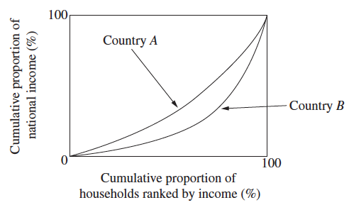
Which of the following statements is most likely to explain the different income distribution in Country A and Country B?
A. Country A has higher rates of saving than Country B.
B. Country A has higher GDP per capita than Country B.
C. Country A has higher incentives for entrepreneurs than Country B.
D. Country A has higher social welfare spending than Country B.

24. The table shows employment data for an economy
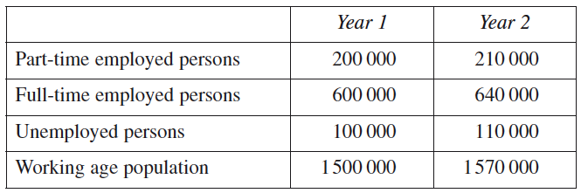
Based on the data in the table, what is the change in the labour force between Year 1 and Year 2?
A. 40 000
B. 50 000
C. 60 000
D. 70 000

End of Section 1

See next page

Section Two: Data interpretation/Short response (36 Marks)
This section contains three (3) questions. Answer all questions. Write your answers in the spaces provided.

Spare pages are included at the end of this booklet. They can be used for planning your responses and/or as additional space if required to continue an answer.
● Planning: If you use the spare pages for planning, indicate this clearly at the top of the page.
● Continuing an answer: If you need to use the space to continue an answer, indicate in the original answer space where the answer is continued, i.e. give the page number. Fill in the number of the question that you are continuing to answer at the top of the page.

Suggested working time: 65 minutes.
___________________________________________________________________________

Question 25 (12 marks)
Sad news for chocolate lovers
Its sad news for chocolate lovers – the price of chocolate is rising! The amount of cocoa the world can produce is set to fall well behind the amount people are eating. Mars Inc., the world’s biggest chocolate maker, says the gap will reach 1 million tons next year and will widen to 2 million tons by 2030. What’s driving the rise in price? Both supply and demand factors. World incomes are rising, especially in the more populous countries of China and India. At the same time, drought and disease are having a devastating effect in some of the major cocoa growing regions of the world.
a. With the aid of a diagram, explain the effect on the chocolate market of an increase in world income. (2 marks)
________________________________________________________________________________________________________________________________________________________________________________________________________________________________________________________________________________________________________________________________________________________________________________________________________________________________________________________________________________________________________________________________________________________

See next page

b. With the aid of a diagram, explain the effect on the chocolate market of a new disease that affects cocoa production. (2 marks)
__________________________________________________________________________________________________________________________________________________________________________________________________________________________________________________________________________________________________________________________________________________________________________________________________________________

See next page
c. With the aid of a diagram, explain the combined effect of a rise in world income and a cocoa disease on the chocolate market. (3 marks)
_________________________________________________________________________________________________________________________________________________________________________________________________________________________________________________________________________________________________________________________________________________________________________________________________________________________________________________________________________________________________________________________________________________________________________________________________________________________________________________________________________________________________________________________________________________________________

See next page

d. Is the demand for all chocolate likely to be price elastic or price inelastic? Is the demand for Mars chocolate bars likely to be price elastic or price inelastic? Give reasons for your answers. (5 marks)
___________________________________________________________________________________________________________________________________________________________________________________________________________________________________________________________________________________________________________________________________________________________________________________________________________________________________________________________________________________________________________________________________________________________________________________________________________________________
___________________________________________________________________
___________________________________________________________________
___________________________________________________________________

See next page
Question 26 (12 marks)
Air pollution may affect students’ grades
High levels of emissions from cars, trucks and buses near your home could hamper a child's grades, according to a new study. The study has found that fourth and fifth graders in the United States who are exposed to toxic air pollutants at home, such as diesel exhaust are more likely to have lower school results. The evidence suggests that this association might exist because of illnesses, such as respiratory infections or asthma and that exposure to air pollution can negatively affect children's brain development.

a. Refer to the extract to explain why air pollution from cars is an example of a negative externality. (2 marks)

_______________________________________________________________________________________________________________________________________________________________________________________________________________________________________________________________________________________________________________________________________________
___________________________________________________________________

b. Distinguish between the private costs and the social costs of the motor vehicle industry. (2 marks)

_______________________________________________________________________________________________________________________________________________________________________________________________________________________________________________________________________________________________________________________________________________
___________________________________________________________________

See next page
c. With the aid of a diagram, show the effect of the negative externality on the motor vehicle industry. (4 marks)

_________________________________________________________________________________________________________________________________________________________________________________________________________________________________________________________________________________________________________________________________________________________________________________________________________________________________________________________________________________________________________________________________________________________________________________________________________________________________________________________________________________________________________________________________________________________________

See next page
d. With the aid of a diagram(s) (if applicable) explain two policies that the government could use to overcome the negative externality. (4 marks)

_______________________________________________________________________________________________________________________________________________________________________________________________________________________________________________________________________________________________________________________________________________
___________________________________________________________________
____________________________________________________________________________________________________________________________________________________________________________________________________________________________________________________________________________

See next page
Question 27 (12 marks)

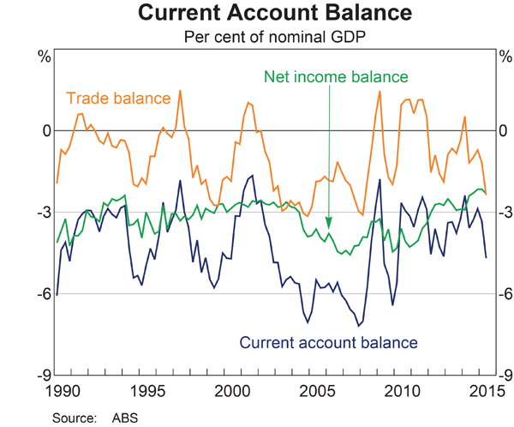

(a) | (i) | Define the term ‘Trade Balance’. | (1 mark )

 | (ii) | What was the trade balance in 2015? | (1 mark )
 | (iii) | What was the Capital and Financial Account Balance in 2015? | (1 mark)

(b) | Describe the components of the current account. | (3 marks)

(c) | Why does Australia have a Current Account Deficit and discuss the implications of a Deficit. | ( 6 marks )

End of Section 2

See next page
Section Three: Extended response (40 Marks)

This section contains four (4) questions. You must answer two (2) questions. Write your answer on the lined pages provided.
Suggested working time: 80 minutes.
___________________________________________________________________

Question 28 (20 marks)

a. Use appropriate model(s) to explain the difference between a price ceiling and a price floor and explain the impact on producers and consumers. Use examples to explain why the government may want to introduce these price regulations into a market and use your models to explain the effects on both price and quantity. (12 marks)

b. Use appropriate model(s) to explain why both taxes and subsidies are inefficient. (8 marks)

Question 29 (20 marks)

- Describe the factors which affect the Price Elasticity of demand. (10 marks)

- Explain why knowledge of elasticity of supply and elasticity of demand is important to business and government. (10 marks)

Question 30 (20 marks)

- Explain the concepts of equity, simplicity and efficiency as they relate to the tax system in Australia. Discuss whether the Personal Income Tax and the Goods and Services Tax (GST) are equitable, simple and efficient. (10 marks)

b. Explain how the government uses the tax and welfare system to try to achieve a more equitable distribution of income.
(10 marks)

Question 31

- Describe the components of aggregate expenditure. (8 marks)

- Describe why investment is more volatile than the other components of aggregate expenditure. (12 marks)
__________________________________________________________________________

End of Exam

